**JUnit Testing**

JUnit is a popular testing framework for Java used to write and run unit tests.

versions: JUnit 4 and JUnit 5 (JUnit Jupiter)

**JUnit Architecture**

Test Class: Contains test methods

Test Method: Annotated with @Test

Assertions: Methods to check expected results (assertEquals, assertTrue, etc.)

**Annotations:**

@Test – marks a test method

@BeforeEach / @Before – runs before each test

@AfterEach / @After – runs after each test

@BeforeAll / @AfterAll – runs once before/after all tests

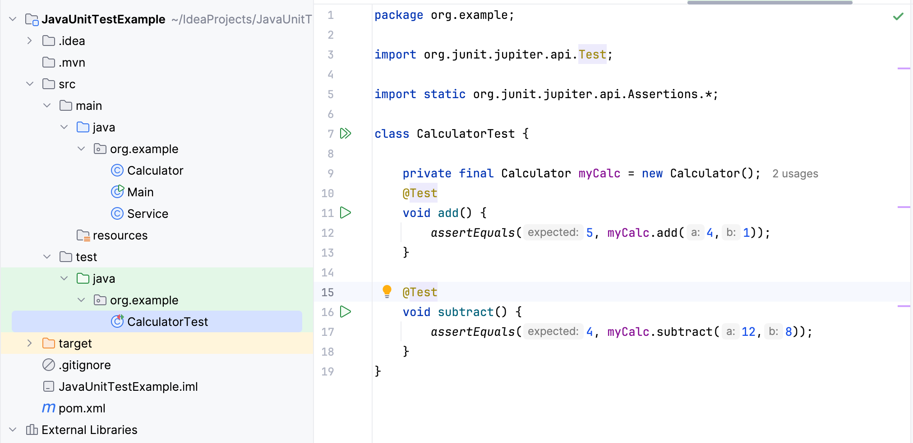

Example of a Test Class Structure:

import org.junit.jupiter.api.Test;

import static org.junit.jupiter.api.Assertions.*;

class CalculatorTest {

@Test

void testAddition() {

Calculator calc = new Calculator();

assertEquals(5, calc.add(2, 3));

}

}

**Common Assertions in JUnit**

| **Assertion** | **Description** | **Example** |
| --- | --- | --- |
| assertEquals(expected, actual) | Checks if two values are equal | assertEquals(5, calc.add(2,3)); |
| assertTrue(condition) | Checks if condition is true | assertTrue(calc.isPositive(3)); |
| assertFalse(condition) | Checks if condition is false | assertFalse(calc.isPositive(-1)); |
| assertThrows(Exception.class, executable) | Checks if a method throws an exception | assertThrows(ArithmeticException.class, () -> calc.divide(5,0)); |
| assertNull(object) | Checks if object is null | assertNull(calc.getValue()); |
| assertNotNull(object) | Checks if object is not null | assertNotNull(calc.getValue()); |

**Writing Your First JUnit Test**

**Step-by-step process:**

Create a class to test (Calculator.java)

Create a JUnit test class (CalculatorTest.java)

Write test methods using @Test

Use assertions to validate expected behavior

Run tests using IDE or Maven/Gradle

class Calculator {

int add(int a, int b) { return a + b; }

int subtract(int a, int b) { return a - b; }

}

import org.junit.jupiter.api.Test;

import static org.junit.jupiter.api.Assertions.*;

class CalculatorTest {

Calculator calc = new Calculator();

@Test

void testAdd() {

assertEquals(5, calc.add(2, 3));

}

@Test

void testSubtract() {

assertEquals(2, calc.subtract(5, 3));

}

}